

RPCDDS – RESTful support
Detailed Design

DOCUMENT INFORMATION
Name | RPCDDS – RESTful support – Detailed design
Product | Documentation
Author | Ricardo González
Distribution | Internal
Version | 0.1
Date | 14th May 2013
Status | Draft
Contact | ricardogonzalez@eprosima.com
Document Code

Table of Contents
Introduction 4
Target 4
Audience 4
Related documentation 4
Definitions and acronyms 4
Evaluation 5
Static structure model 8
Study of WADL 9
Mapping WADL to RPCDDS IDL 9
How WADL maps remote procedures into HTTP messages 24
IDL compiler 24
Type serialization 24
Client side 26
Server side 28
RPCDDS 30
Transports 30
Proxy 32
Server 36
Behavior model 41
DDS 41
Proxy initialization 41
Using proxy to call a remote procedure synchronously 42
Server initialization 42
Server receives a request 43
RESTful 44
Proxy initialization 44
Using proxy to call a remote procedure synchronously 45
Server initialization 46
Server receives a request 47
Revision history
Date | Author | Description
14-Janury-2013 | Ricardo González (ricardogonzalez@eprosima.com) | First version.

Introduction

Target
The purpose of this document is to design a new feature in RPCDDS. RESTful architectural style will be supported in RPCDDS. This means that a client application developed with RPCDDS could call remote procedures of a remote server that provides a RESTful interface. Also a server application developed with RPCDDS could provide a RESTful interface to client applications.

Audience
This document has been written for the developers of this project.

Related documentation
- Web Application Description Language Submission

Definitions and acronyms
WADL: Web Application Description Language

Evaluation
The new implementation must implement next features to achieve complete RESTful support.
- WADL support. WADL is used to describe RESTful web services. Considering that RESTful wants to be supported in RPCDDS, a user should be able to describe its remote procedure calls in this description language. Then there must be a mapping between the RPCDDS IDL format and the WADL format. The goal of this mapping is to create an application that is capable of transform WADL file to a RPCDDS IDL file and vice versa.
- Future RPCDDS API for users has to coexist with current RPCDDS API and it will increase its functionality. Some example of this new functionality would be: user could connect a remote server using RESTful or user could create a server that supports RESTful and RPC using DDS.
- RPCDDS should provide an internal API to serialize and deserialize RESTful data. This internal API comes out from the study of how WADL represents its content in the HTTP protocol and the study of mapping WADL and RPCDDS IDL.
- RPCDDS code generator must generate specific code to serialize and deserialize the remote procedures defined by user using RPCDDS IDL. For this purpose this specific code will use the internal API to serialize and deserialize RESTful data.
- RPCDDS will implement one or more transports that allow sending and receiving HTTP packages. The main transport should be a TCP transport.
- RPCDDS should implement a mechanism to know the source of a request, whether it comes from DDS or a Restful transport. This knowledge is useful to know where the reply has to be sent, using DDS or the Restful transport.
This section will evaluate the coexistence between the current RPCDDS implementation and the new features’ implementation. First step is to review the current architecture of RPCDDS.
DDS
ClientRPC
ClientRPC
ClientRPC
ServerRPC
ServerRPC
ServerRPC
Client
Server
RPCDDS: Current architecture

When a user implements a client application, its application interacts with an object that acts like a server’s proxy. This object exposes the set of remote procedures of the remote server. Common functionality of this object is implemented by the class eProsima::DDSRPC::Client. Also this class manages the DDS::DomainParticipant entity.
For each remote procedure, the class eProsima::DDSRPC::Client manages an object. This object manages the call of the remote procedure that a user makes. The common functionality of this object is inherited from the class eProsima::DDSRPC::ClientRPC. Also this class manages the DDS::DataWriter entity which sends the request and the DDS::Datareader entity which receives the reply.
When a user implements a server application, user has to implement a generated skeleton. This skeleton is managed by an object that acts like the server. The common functionality of this object is inherited by the class eProsima::DDSRPC::Server. This class also manages the DDS::DomainParticipant entity.
For each remote procedure, the class eProsima::DDSRPC::Server manages an object. This object manages the reception of requests from a remote procedure that a client makes. The common functionality of this object is inherited by the class eProsima::DDSRPC::ServerRPC. Also this class manages the DDS::Datareader entity which receives the request and the DDS::Datawriter entity which sends the reply.
Having seen the current architecture, next step is to find out the common points that current implementation and new features’ implementation will have in the future implementation.
At user’s level, the interaction has to be the same. In the case of a client application, the server’s proxy has to exposes the set of remote procedures as it exposes in the current implementation. Also in the case of a server application, the skeleton has to be generated in the same way.
After a client application calls a remote procedure using the server’s proxy, it could be seen common steps in the way a remote procedure is carried out using DDS and using RESTful.
First it will be analyzed the way using DDS. When a client application calls a remote procedure using the server’s proxy, the remote procedure and its input parameters are encapsulated in a DDS type. You could say that there was a serialization of the remote procedure and its input parameters. Then the DDS type is sent using DDS. DDS is acting as a transport. When DDS receives a reply, this reply is a DDS type. Output parameters of the remote procedure were get deserializing the DDS type and then they are returned to the client application.
Now when a client application wants to use RESTful, the input parameters of the remote procedure will be encapsulated in a HTTP message. Then this HTTP message will be sent using a transport that works with a socket in its low-level. When the transport receives a reply, this reply is an HTTP message. Output parameters of the remote procedure get deserializing the HTTP message and then they are returned to the client application.
In the design of new RPCDDS implementation it will be taken into account that there are two common points: both mechanisms use a protocol to serialize and deserialize, and both use a way to send and receive the data.

Static structure model
The proposed model in this document tries to give an RPC framework for the user. The internal use of subscriber/publisher architecture or RESTful philosophy must to be transparent. The user only wants to execute remote procedures and obtain the results. This document will be focused in the RESTful philosophy and its integration in the RPCDDS product.
In RESTful the concept of remote procedure call is mapped in sending a request from client to the server and receiving a reply in the other way. Both, request and reply, are HTTP messages. How RPCDDS will map remote procedures in a HTTP messages is defined by WADL. The section 3.1 makes a study of WADL. The subsection 3.1.2studies how WADL maps its definitions in HTTP methods. This will help in the creation of an internal API in the section (TODO: insert section). This API will be use to serialize definitions in RPCDDS IDL into HTTP messages. The subsection 3.1.1 studies how to convert a WADL file into a RPCDDS IDL file.
As it was commented, one common point for DDS and RESTful is the serialization. Both mechanisms have to serialize the remote procedure and its parameters. Section 3.2.1 explains the protocol classes that must be generated and they are responsible for serializing the remote procedure and its parameters.
Whether DDS middleware is seen like a transport, the other common point is the transport level. There will be several transports. One of them encapsulates the usage of DDS middleware to send the DDS data, and the others are used to send RESTufl protocol data. Section 3.3.1 explains the transport classes.
IDL compiler continues to be an important part in the design. From now on IDL compiler not only generates code to serialize into DDS types, but it will generate code to serialize into HTTP messages. Section 3.2 talks about the changes in the IDL compiler.
In the rest of this document when it appears a generated class or generated code by the IDL compiler, the next RPCDDS IDL example will be use:
// file Bank.idl

#include “ReturnedCodes.idl”

module www_santander_es
{
[RESOURCES_BASE_URI(“http://www.santander.es/”)]

[Path(“{accountNumber}”)]
interface AccountResource
{
struct Account
{
string accountNumber;
};

union AccountResponse switch(long)
{
case 200:
ReturnOK returnOK;
case 400:
ReturnServerError returnServerError;
};

[PUT]
AccountResponse deposit(in Account account, in string username,
in string password, in long money);
};
};

Study of WADL
WADL is designed to provide a machine process-able description of HTTP-based Web applications. WADL describes the following aspects of a Web application:
- Set of resources. Analogous to a site map showing the resources on offer.
- Relationships between resources. Describing the links between resources, both referential and causal.
- Methods that can be applied to each resource. The HTTP methods that can be applied to each resource, the expected inputs and outputs and their supported formats.
- Resource representation formats. The supported MIME types and data schemas in use.
RPCDDS IDL should be able to describe these aspects too. For this purpose this study will be map the WADL description components to RPCDDS IDL and some new improvements should be added to RPCDDS IDL to support some features.

Mapping WADL to RPCDDS IDL
This section describes the WADL description components and how they could be mapped in RPCDDS IDL. All WADL elements have the following XML namespace name:
http://wadl.dev.java.net/2009/02

Cross referencing
Several WADL components support references to other components. Note that references are URI references, not ID references, and therefore support both intra- and inter-document cross referencing. This first version only will support intra-document cross referencing. Intra-document references are made using fragment identifiers, e.g. #someid.

Application
The application element forms the root of a WADL description and contains the following:
- Zero or more doc elements – see section 3.1.1.3
- An optional grammars element – see section 3.1.1.4
- Zero or more resources elements – see section 3.1.1.5
- Zero or more of the following:
  - resource_type elements – see section 3.1.1.7
  - method elements – see section 3.1.1.8
  - representation elements – see section 3.1.1.11
  - param elements – see section 3.1.1.12
This element doesn't need to be mapped to RPCDDS IDL. The main IDL file will contain all elements that application element contains.
In the case that a target namespace is defined, all elements that the application element contains will be contained inside an IDL module element whose name will be gotten from the target namespace. XML target namespace are defined in the root of the XML document. In this case the root is the application element. The target namespace is defined with the field xmlns:tns or targetNamespace whose types is xsd:anyURI.
The IDL module element has an identifier. Identifiers in RPCDDS IDL are defined:
<ID : ["a"-"z","A"-"Z", "_"] (["a"-"z","A"-"Z","0"-"9","_"])* >
As the type of target namespace supports more characters there will be some rules to get the identifier of the IDL module element.
- Everything before the final ‘/’ is not mapped.
- All incompatible characters will be substituted by the character ‘_’.
The following WADL example:
<?xml version="1.0"?>
<application xmlns:xsi="http://www.w3.org/2001/XMLSchema-instance"
xsi:schemaLocation=http://wadl.dev.java.net/2009/02 wadl.xsd
xmlns:tns="urn:yahoo:yn"
xmlns:xsd=http://www.w3.org/2001/XMLSchema
xmlns="http://wadl.dev.java.net/2009/02">
</application>
The RPCDDS IDL generated will be:
module urn_yahoo_yn
{

};

Documentation
In this first release the documentation element will not parsed to IDL.

Gramars
The grammars element acts as a container for definitions of the format of data exchanged during execution of the protocol described by the WADL document. Such definitions may be included inline or by reference using the include element (see section 3.1.1.4.1).
No particular data format definition language is mandated. But RPCDDS imposes a limitation: W3C XML Schema must be used to define data format. (TODO: put reference) The appendix A describes how to map XML Schema to RPCDDS IDL.

Include
The include element allows the definitions of one or more data format descriptions to be included by reference. The href attribute provides a URI for the referenced definitions and is of type xsd:anyURI.
The include element will be mapped to the preprocessor tag #include. The URI of href attribute must reference a XML Schema file. As also assumes that this file has been mapped to RPCDDS IDL the preprocessor tag #include must reference the IDL file version. The following WADL example:
<?xml version="1.0"?>
<application xmlns:xsi="http://www.w3.org/2001/XMLSchema-instance"
xsi:schemaLocation=http://wadl.dev.java.net/2009/02 wadl.xsd
xmlns:tns="urn:yahoo:yn"
xmlns:xsd=http://www.w3.org/2001/XMLSchema
xmlns="http://wadl.dev.java.net/2009/02">
<grammars>
<include href="NewsSearchResponse.xsd"/>
<include href="Error.xsd"/>
</grammars>
</application>
The RPCDDS IDL generated will be:
#include “NewsSearchResponse.idl”
#include “Error.idl”

module urn_yahoo_yn
{

};

Resources
The resources element acts as a container for the resources provided by the application. A resources element has a base attribute of type xsd:anyURI that provides the base URI for each child resource identifier.
This WADL element only set the base URI. This element will be mapped as an annotation. The name of this annotation is RESOURCES_BASE_URI.
The following WADL example:
<?xml version="1.0"?>
<application xmlns:xsi="http://www.w3.org/2001/XMLSchema-instance"
xsi:schemaLocation=http://wadl.dev.java.net/2009/02 wadl.xsd
xmlns:tns="urn:yahoo:yn"
xmlns:xsd=http://www.w3.org/2001/XMLSchema
xmlns="http://wadl.dev.java.net/2009/02">
<grammars>
<include href="NewsSearchResponse.xsd"/>
<include href="Error.xsd"/>
</grammars>
<resources base="http://api.search.yahoo.com/NewsSearchService/V1/">
</resources>
</application>
The RPCDDS IDL generated will be:
#include “NewsSearchResponse.idl”
#include “Error.idl”

module urn_yahoo_yn
{
[RESOURCES_BASE_URI(“http://api.search.yahoo.com/NewsSearchService/V1/”)]
};

Resource
A resource element describes a set of resources, each identified by a URI that follows a common pattern. A resource element has the following attributes:
- id – An optional attribute of type xsd:ID that identifies the resource element.
- path – An optional attribute of type xsd:string. If present, it provides a relative URI template for the identifier of the resource. The resource’s base URI is given by the resource elements’s parent resource of resources element.
- type – An optional attribute whose type is a space separated list of xsd:anyURI. Each value in the list is a cross reference (see section Cross Referencing) that identifies a resource-type element (see section ) that defines a set of methods.
- queryType – Defines the media type for the query component of the resource URI. Defaults to 'application/x-www-form-urlencoded' if not specified which results in query strings being formatted as specified in section 17.13 of HTML 4.01[3]
For each resource it will be create an iDL interface. This interface will contain the methods that can be applied on this resource. If the attribute id was defined, it will be used to set the interface's name. In other case the attribute path will be used. The interface's name is ended with the word 'Resource'.
The following WADL example:
<?xml version="1.0"?>
<application xmlns:xsi="http://www.w3.org/2001/XMLSchema-instance"
xsi:schemaLocation=http://wadl.dev.java.net/2009/02 wadl.xsd
xmlns:tns="urn:yahoo:yn"
xmlns:xsd=http://www.w3.org/2001/XMLSchema
xmlns="http://wadl.dev.java.net/2009/02">
<grammars>
<include href="NewsSearchResponse.xsd"/>
<include href="Error.xsd"/>
</grammars>
<resources base="http://api.search.yahoo.com/NewsSearchService/V1/">
<resource path="newsSearch">
</resource>
</resources>
</application>
The RPCDDS IDL generated will be:

#include “NewsSearchResponse.idl”
#include “Error.idl”

module urn_yahoo_yn
{
[RESOURCES_BASE_URI(“http://api.search.yahoo.com/NewsSearchService/V1/”)]

[PATH(newsSearch)]
interface newsSearchResource
{
};
};
A resource element contains the following child elements:
- Zero or more doc elements – see section 3.1.1.3.
- Zero or more param elements (see section 3.1.1.12)with one of the following values for its style attribute:
  - template Provides additional information about an embedded template parameter, see above. Child param elements whose name attribute value does not match the name of an embedded template parameter are ignored.
  - matrix Specifies a matrix URI parameter
  - query Specifies a global URI query parameter for all child method elements of the resource. Does not apply to methods inherited from a resource_type specified using the type attribute.
  - header Specifies a global HTTP header for use in the request part of all child method elements of the resource. Does not apply to methods inherited from a resource_type specified using the type attribute.
- Zero or more method (see section 3.1.1.8) elements, each of which describes the input to and output from an HTTP protocol method that can be applied to the resource. Such locally-defined methods are added to any methods included in resource_type elements referred to using the type attribute.
- Zero or more resource elements that describe sub-resources. Such sub-resources inherit matrix and template parameters from the parent resource since their URI is relative to that of the parent resource but they do not inherit query or header parameters specified globally for the parent resource.
The value of the path attribute may be static or may contain embedded template parameters. If there is present some template parameter, a structure will be created in the IDL that contains the template parameters. This structure will be the first parameter in each generated method for the interface.
Additional information about embedded template parameters can be conveyed using a child param element with a style attribute value 'template' whose name attribute value matches the name of the parameter embedded in the template. In the following example the type of the widgetId template parameter is specified by the child param element:
<resource path="widgets/{widgetId}">
<param name="widgetId" style="template" type="xsd:int"/>
...
</resource>
The RPCDDS IDL generated will be:
[PATH(“widgets/{widgetId}”)]
interface widgets_widgetIdResource
{
struct widgets_widgetId
{
long widgetId;
}
};

Resource type
A resource_type element describes a set of methods that, together, define the behavior of a type of resource. A resource_type may be used to define resource behavior that is expected to be supported by multiple resources. This element will not be supported in the first release.

Method
A method element describes the input to and output from an HTTP protocol method that may be applied to a resource. A method element can either be a method definition or a reference to a method defined elsewhere.

Method reference
A method reference element is a child of a resource element that has an href attribute whose type is xsd:anyURI. The value of the href attribute is a cross reference (see section 3.1.1.1) to a method definition element. This form of method element may be used to reduce duplication when the same method applies to more than one resource.
In this case the method definition will be looked for using the cross reference and the method will be used as it is explained in next subsection.

Method definition
A method definition element is a child of a resource or application element and has the following attributes:
- name Indicates the HTTP method used.
- id An identifier for the method, required for globally defined methods, not allowed on locally embedded methods. Methods are identified by an XML ID and are referred to using a URI reference.
A method definition is converted in an IDL function. This function is located inside the interface of the resource that this method is applied for.
The following WADL example:
<?xml version="1.0"?>
<application xmlns:xsi="http://www.w3.org/2001/XMLSchema-instance"
xsi:schemaLocation=http://wadl.dev.java.net/2009/02 wadl.xsd
xmlns:tns="urn:yahoo:yn"
xmlns:xsd=http://www.w3.org/2001/XMLSchema
xmlns="http://wadl.dev.java.net/2009/02">
<grammars>
<include href="NewsSearchResponse.xsd"/>
<include href="Error.xsd"/>
</grammars>
<resources base="http://api.search.yahoo.com/NewsSearchService/V1/">
<resource path="newsSearch">
<method name="GET" id="search">
</method>
</resource>
</resources>
</application>
The RPCDDS IDL generated will be:
#include “NewsSearchResponse.idl”
#include “Error.idl”

module urn_yahoo_yn
{
[RESOURCES_BASE_URI(“http://api.search.yahoo.com/NewsSearchService/V1/”)]

[PATH(“newsSearch”)]
interface newsSearchResource
{
[GET]
void search();
};
};
It is permissible to have multiple child method elements that have the same value of the name attribute for a given resource; such siblings represent distinct variations of the same HTTP method and will typically have different input data.
A method element has the following child elements:
- doc Zero or more doc elements – see section 3.1.1.3.
- request Describes the input to the method as a collection of parameters and an optional resource representation – see section 3.1.1.9.
- response Zero or more response elements that describe the possible outputs of the method – see section 3.1.1.10.
All response elements will be encapsulated in a union. The following WADL example:

<?xml version="1.0"?>
<application xmlns:xsi="http://www.w3.org/2001/XMLSchema-instance"
xsi:schemaLocation=http://wadl.dev.java.net/2009/02 wadl.xsd
xmlns:tns="urn:yahoo:yn"
xmlns:xsd=http://www.w3.org/2001/XMLSchema
xmlns="http://wadl.dev.java.net/2009/02">
<grammars>
<include href="NewsSearchResponse.xsd"/>
<include href="Error.xsd"/>
</grammars>
<resources base="http://api.search.yahoo.com/NewsSearchService/V1/">
<resource path="newsSearch">
<method name="GET" id="search">
<response status="200">
</response>
<response status="400">
</response>
</method>
</resource>
</resources>
</application>
The RPCDDS IDL generated will be:
#include “NewsSearchResponse.idl”
#include “Error.idl”

module urn_yahoo_yn
{
[RESOURCES_BASE_URI(“http://api.search.yahoo.com/NewsSearchService/V1/”)]

[PATH(“newsSearch”)]
interface newsSearchResource
{
union newsSearchResponse
{
};

[GET]
newSearchResponse search();
};
};

Request
A request element describes the input to be included when applying an HTTP method to a resource. A request element has no attributes and may contain the following child elements:
- Zero or more doc elements – see section 3.1.1.3.
- Zero or more representation elements – see section 3.1.1.11. Note that use of representation elements is confined to HTTP methods that accept an entity body in the request (e.g., PUT or POST). Sibling representation elements represent logically equivalent alternatives, e.g., a particular resource might support multiple XML grammars for a particular request.
- Zero or more param elements (see section 3.1.1.12) with one of the following values for their style attribute:
  - query Specifies a URI query parameter for all methods that apply to this resource, see section 3.1.1.9.1
  - header Specifies a HTTP header for use in the request

Query parameters
Child param elements (see section 3.1.1.12) of a resource or request with a style value of 'query' represent URI query parameters as described in section 17.13 of HTML 4.01[3]. The runtime values of query parameters are sent as URI query parameters when the HTTP method is invoked.
These child param elements of a resource or request are transformed into parameter of the IDL function. The following WADL example:
<resources base="http://example.com/widgets">
<resource path="{widgetId}">
<param name="customerId" style="query"/>
<method name="GET">
<request>
<param name="verbose" style="query" type="xsd:boolean"/>
</request>
<response>
...
</response>
</method>
</resource>
</resources>
The RPCDDS IDL generated will be:
[RESOURCES_BASE_URI(“http://example.com/widgets”)]

[PATH(“{widgetId}")]
interface widgetIdResource
{
struct widgetId
{
long widgetId;
}

[GET]
void get(in widgetId widgetId, in long customerId, in bool verbose);
};
};

Response
A response element describes the output that results from performing an HTTP method on a resource. It has the following attributes:
- status Optionally present on responses, provides a list of HTTP status codes associated with a particular response.
- A response element may contain the following child elements:
  - Zero or more doc elements (see section 3.1.1.3).
  - Zero or more representation elements (see section 3.1.1.11), each of which describes a resource representation that may result from performing the method. Sibling representation elements indicate logically equivalent alternatives; normal HTTP content negotiation mechanisms may be used to select a particular alternative.
  - Zero or more param elements (see section 3.1.1.12) with a value of 'header' for their style attribute, each of which specifies the details of a HTTP header for the response
A method can return several response elements. All these response elements are returned in a union as was described in section 3.1.1.8. Also a response element will be transformed into a structure that contain the response information.
The following WADL example:
<?xml version="1.0"?>
<application xmlns:xsi="http://www.w3.org/2001/XMLSchema-instance"
xsi:schemaLocation=http://wadl.dev.java.net/2009/02 wadl.xsd
xmlns:tns="urn:yahoo:yn"
xmlns:xsd=http://www.w3.org/2001/XMLSchema
xmlns="http://wadl.dev.java.net/2009/02">
<grammars>
<include href="NewsSearchResponse.xsd"/>
<include href="Error.xsd"/>
</grammars>
<resources base="http://api.search.yahoo.com/NewsSearchService/V1/">
<resource path="newsSearch">
<method name="GET" id="search">
<response status="200">
</response>
<response status="400">
</response>
</method>
</resource>
</resources>
</application>
The RPCDDS IDL generated will be:
#include “NewsSearchResponse.idl”
#include “Error.idl”

module urn_yahoo_yn
{
[RESOURCES_BASE_URI(“http://api.search.yahoo.com/NewsSearchService/V1/”)]

[PATH(“newsSearch”)]
interface newsSearchResource
{
struct Response1
{
};

struct Response2
{
};

union newsSearchResponse switch(long)
{
case 200:
Response1 response1;
case 400:
Response2 response2;
};

[GET]
newSearchResponse search();
};
};

Representation
A representation element describes a representation of a resource's state. A representation element can either be a representation definition or a reference to a representation defined elsewhere.

Representation reference
A representation reference element can be a child of a request or response element. It has a href attribute of type xsd:anyURI. The value of the href attribute is a cross reference (see section 3.1.1.1) to a representation definition element. This form of representation element may be used to reduce duplication when the same representation is used in multiple locations.
In this case the representation definition will be looked for using the cross reference and the representation will be used as it is explained in next subsection.

Representation definition
A representation definition element can be a child of a request, response or application element. It has the following attributes:
- id An identifier for the representation, required for globally defined representations, not allowed on locally embedded representations. Representations are identified by an XML ID and are referred to using a URI reference.
- mediaType Indicates the media type of the representation. Media ranges (e.g. text/*) are acceptable and indicate that any media type in the specified range is supported.
- element For XML-based representations, specifies the qualified name of the root element as described within the grammars section – see section 3.1.1.4.
In addition to the attributes listed above, a representation definition element can have zero or more child doc elements (see section 3.1.1.3) and param elements (see section 3.1.1.12).
In the current implementation only is supported XML as media type. This XML representation will be defined using XSD. The attribute element indicates the root element of its XML Schema representation. The following WADL example:
<?xml version="1.0"?>
<application xmlns:xsi="http://www.w3.org/2001/XMLSchema-instance"
xsi:schemaLocation=http://wadl.dev.java.net/2009/02 wadl.xsd
xmlns:tns="urn:yahoo:yn"
xmlns:xsd=http://www.w3.org/2001/XMLSchema
xmlns="http://wadl.dev.java.net/2009/02">
<grammars>
<include href="NewsSearchResponse.xsd"/>
<include href="Error.xsd"/>
</grammars>
<resources base="http://api.search.yahoo.com/NewsSearchService/V1/">
<resource path="newsSearch">
<method name="GET" id="search">
<request>
<param name="appid" type="xsd:string"
style="query" required="true"/>
<param name="query" type="xsd:string"
style="query" required="true"/>
</request>
<response status="200">
representation mediaType="application/xml"
element="yn:ResultSet"/>
</response>
<response status="400">
<representation mediaType="application/xml"
element="ya:Error"/>
</response>
</method>
</resource>
</resources>
</application>
The RPCDDS IDL generated will be:
#include “NewsSearchResponse.idl”
#include “Error.idl”

module urn_yahoo_yn
{
[RESOURCES_BASE_URI(“http://api.search.yahoo.com/NewsSearchService/V1/”)]

[PATH(“newsSearch”)]
interface newsSearchResource
{
struct Response1
{
yn::ResultSet representation;
};

struct Response2
{
ya::Error representation;
};

union newsSearchResponse switch(long)
{
case 200:
Response1 response1;
case 400:
Response2 response2;
};

[GET]
newSearchResponse search();
};
};

Parameter
A param element describes a parameterized component of its parent element. A param element can either be a parameter definition or a reference to a parameter defined elsewhere.

Parameter reference
A param reference element is a param element that has an href attribute whose type is xsd:anyURI. The value of the href attribute is a cross reference (see section 3.1.1.1) to a param definition element. This form of param element may be used to reduce duplication when the same parameter applies to more than one parent.

Parameter definition
A param definition element describes a parameterized component of its parent element and may be a child of a resource (see section 3.1.1.6), application (see section 3.1.1.2), request (see section 3.1.1.9), response (see section 3.1.1.10), or a representation (see section 3.1.1.11) element. A param definition element has zero or more doc child elements (see section 3.1.1.3), zero or more option child elements (see section 24), and has the following attributes:
- id An optional identifier that may be used to refer to a parameter definition using a URI reference.
- name The name of the parameter as an xsd:NMTOKEN. Required.
- style Indicates the parameter style, next table lists the allowed values and shows the context(s) in which each value may be used.
- type Optionally indicates the type of the parameter as an XML qualified name, defaults to xsd:string.
- default Optionally provides a value that is considered identical to an unspecified parameter value.
- path When the parent element is a representation element, this attribute optionally provides a path to the value of the parameter within the representation. For XML representations, use of XPath 1.0[4] is recommended.
- required Optionally indicates whether the parameter is required to be present or not, defaults to false (parameter not required).
- repeating Optionally indicates whether the parameter is single valued or may have multiple values, defaults to false (parameter is single valued).
- fixed Optionally provides a fixed value for the parameter.

Value | Parent Element(s) of param | Usage | Supported
matrix | resource | Specifies a matrix URI component. | NOT
header | resource, resource_type, request or response | Specifies a HTTP header that pertains to the HTTP request (resource or request) or HTTP response (response) | YES
query | resource, resource_type or request | Specifies a URI query parameter represented according to the rules for the query component media type specified by the queryType attribute. | YES
query | representation | Specifies a component of the representation as a name value pair formatted according to the rules of the media type. Typically used with media type 'application/x-www-form-urlencoded' or 'multipart/form-data'. | NOT
template | resource | The parameter is represented as a string encoding of the parameter value and is substituted into the value of the path attribute of the resource element as described in section 2.6.1. | YES
plain | representation | Specifies a component of the representation formatted as a string encoding of the parameter value according to the rules of the media type. | NOT

Option
TODO

How WADL maps remote procedures into HTTP messages
Using the information above in the section 3.1.1 and the information of how are created the HTTP messages, this section will explain how the HTTP messages will be created when RESTful is used by RPCDDS.
TODO Study a library to create HTTP messages.

IDL compiler
This section explains the classes and functions that have to be generated by the IDL compiler. In each section former it will be described the changes that should done in the current DDS architecture . Later it will be described the new changes to support RESTful.

Type serialization
As this project currently uses the DDS standard, the last information that is sent and received is DDS types. Then IDL compiler generates DDS Types and functions to encapsulate the remote procedures and their parameters in these DDS Types. These implemented functions for each remote procedure have the following functionality:
- Encapsulate the remote procedure and its input parameters in a request. The type of this request is a DDS type. This functionality is used in the client side. In the example this type depositRequest.
struct depositRequest{
Identification clientServiceId; //@key
unsigned long numSec; //@key
Account ac;
string username;
string password;
long money;
}; //@top-level true
- Extract the remote procedure and its input parameters from a request. This functionality is used in the server side. In the example this type is depositRequest.
- Encapsulate the remote procedure and its output parameters in a reply. The type of this reply is a DDS type. This functionality is used in the server side. In the example this type depositReply:
struct depositReply{
Identification serverServiceId; //@key
Identification clientServiceId; //@key
unsigned long numSec; //@key
long ddsrpcRetCode;
union AccountResponse deposit_ret;
}; //@top-level true
- Extract the remote procedure and its output parameters from a reply. This functionality is used in the client side. In the example this type depositReply.
For the IDL example, this functionality will be implemented statically by the class DDS::BankProtocol.
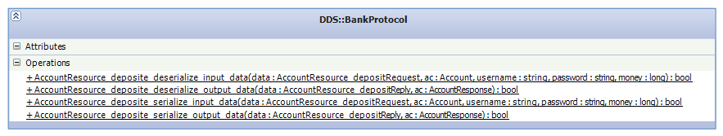
Now there will be other serialization/deserialization mechanism. IDL compiler has to generate functions that:
- Encapsulate the remote procedure and its input parameters in a HTTP message (see section 3.1.2). This functionality is used in the client side.
- Detect the interface that is the destination of the remote procedure, extract the output parameters from the HTTP message and call to the method skeleton. This functionality is used in the server side. This functionality is wider than its version in DDS. When a data is received in DDS version, the type of this data is known because it was received through its datareader. But in the RESTful server all remote procedures come in through the transport. The IDL compiler will generate a function that can detect what interface is the destination, what method of this interface is in the HTTP message and if the interface was registered then the parameters will be extracted.
- Encapsulate the remote procedure and its output parameters in a HTTP message. This functionality is used in the server side.
- Extract the remote procedure and its output parameters from a HTTP message. This functionality is used in the client side.
For the example IDL, this functionality will be implemented statically by the class REST::BankProtocol.
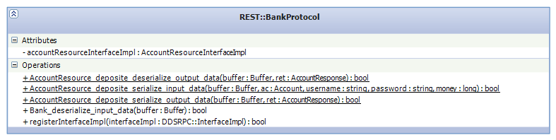
This new RPCDDS version will support multiple interfaces. Then a new feature will be added. User will be able to register in the server the interfaces that it wants to be available. This feature will be in the DDS and RESTful support. For RESTful support, the class REST::BankProtocol needs the function registerInterfaceImpl. This function is called by the server side when a user has registered an interface and it sets the interface inside the protocol class. If it is received a remote procedure to a registered interface, it will be deserialized and passed to the interface. In other case, the server will return a HTTP error to the client.
DDS::BankProtocol will use the generated code by the application rtiddsgen to serialize/deserialize as it does right now. REST::BankProtocol will use the API described in section (TODO: set section number) to serialize/deserialize.

Client side
In the client's side, current DDS architecture will change to coexist with new RESTful support. The client's proxy will have less functionality than earlier version. In new architecture the client's proxy doesn't inherit from a base class that controls the DDS::DomainParticipant. In the section 2 it was commented that in the new architecture DDS will be seen as a transport. This transport will manage the DDS:DomainParticipant, as it is explained in section 3.3.1.1. Then the new client's proxy expects an instance of this transport.
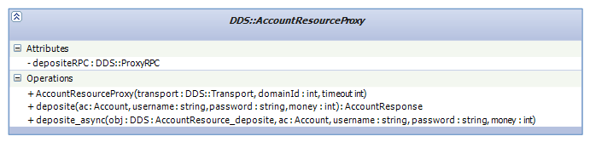
As new RPCDDS version will support multiple interfaces, for each interface will be generated a client's proxy. In our IDL example only one interface will be generated:
For each remote procedure will continue to create a class that encapsulates its DDS entities and its usage. These classes will be called as RPC endpoint classes. These classes will be registered in the DDS transport which will register them in the DDS::DomainParticipant. In our IDL example only one class will be generated for the remote procedure deposite:
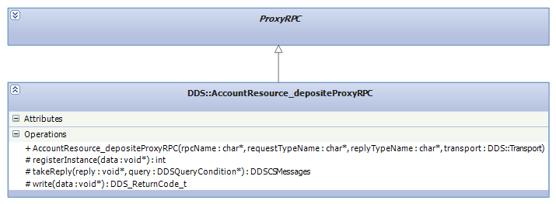
The client's proxies that are generated for RESTful support should have the same interface than the generated for DDS. There is only one different. RESTful proxy's constructors expect a transport that supports RESTful and don't need the DDS domain identifier. In our IDL example the genereated client's proxy will be:
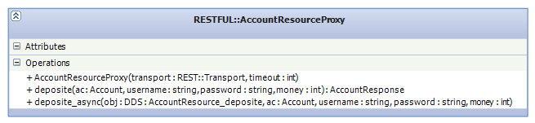
IDL compiler has not to generate a class per remote procedure as it does for DDS. When the user calls a remote procedure, the HTTP message is created using the protocol class and then this message is sent using the transport.

Server side
As in the client side, current DDS architecture of the server side will change to coexist with new RESTful support. The server will also have less functionality than earlier version. In new architecture the server doesn't inherit from a base class that controls the DDS::DomainParticipant. In the section 2 it was commented that in the new architecture DDS will be seen as a transport. This transport will manage the DDS:DomainParticipant, as it is explained in section 3.3.1.1. Then the new server expects an instance of this transport. In our IDL example the generated server will be:
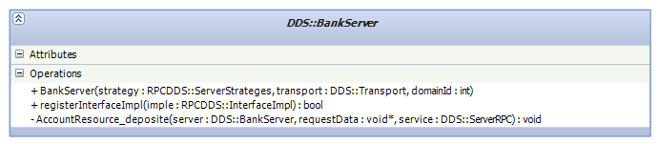
As new RPCDDS version will support multiple interfaces, user will be able to register the interfaces that he wants to be available in his server. User will use the function registerInterfaceImpl for this purpose. The implementation of an interface is an object that has to inherit from a virtual class that defines all remote procedures. This virtual class also inherits from the interface DDSRPC::InterfaceImpl and the virtual class is generated too by the IDL compiler. In our IDL example this virtual class is:
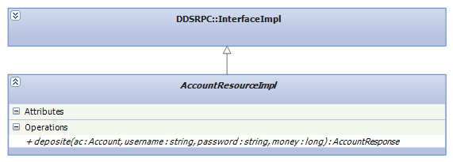
For each remote procedure will continue to create a class that encapsulates its DDS entities and its usage. These classes will be registered in the DDS transport which will register them in the DDS::DomainParticipant. In our IDL example only one class will be generated for the remote procedure deposite:
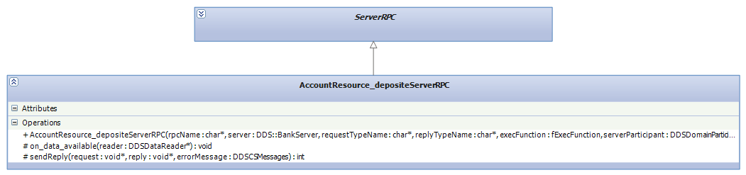
The server that are generated for RESTful support should have the same interface than the generated for DDS. There is only one different. RESTful server's constructors expect a transport that supports RESTful and don't need the DDS domain identifier. In our IDL example the genereated server will be:
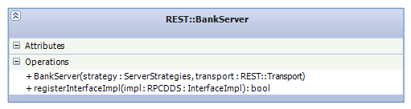

The generated server for RESTful also permit to register the interfaces that the user wants to be available in this server. The user could use the same virtual class that is used in DDS. This virtual class is compatible between DDS and RESTful.
IDL compiler has not to generate a class per remote procedure as it does for DDS. When a request is received, the HTTP message is deserialized using the protocol class and then the message is passed to the corresponding interface.

RPCDDS

Transports
This section will explain the new transports that RPCDDS will offer. These transports are divided. Ones will be used in RPC communications over DDS. The other will be used in RESTful communications.

RPC over DDS transports
In the previous architecture the management of the DDS::DomainParticipant entity was located in the main proxy class and main server class. This creates a limitation: only one IDL interface is supported. But this limitation cannot exist in the new implementation. Therefore the management of the DDS::DomainParticipant has been extracted from those classes.
Such as was described in the section 2, the DDS communication will be seen as a transport. There will be a class that implements this transport. When this class is constructed, it will create the DDS::DomainParticipant entity and the class will manage it.
There will be different transports between the client's side and the server's side. But in both cases the user will be able to use a DDS transport that uses TCP or a DDS transport that uses UDP.
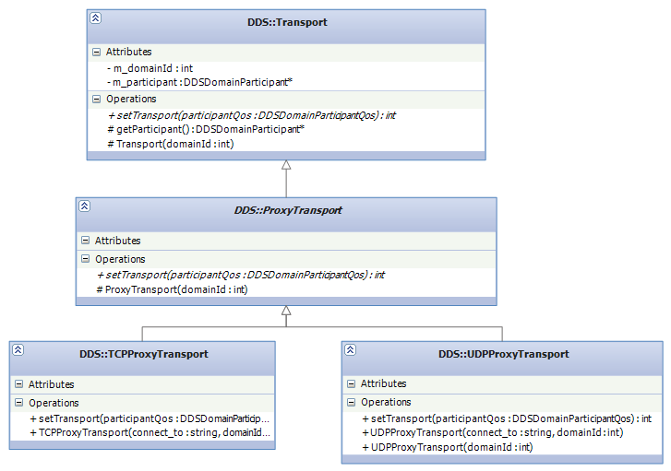Illustration 1: DDS transport for client side
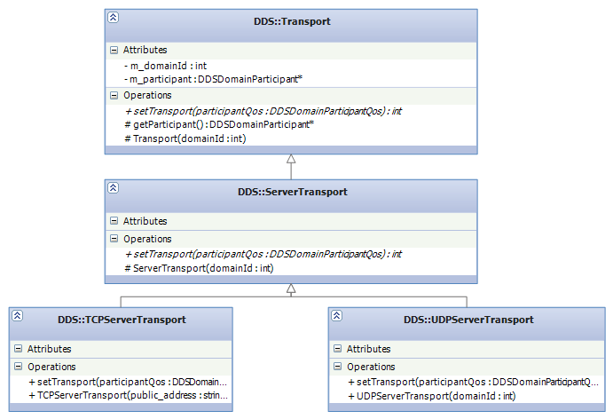Illustration 2: DDS transport for server side

RESTful transports
In this new architecture only one transport will be implemented. Usually a TCP connection is used to send HTTP messages. RPCDDS will offer a TCP transport to send and receive HTTP messages. There will be different transports between the client's side and the server's side.
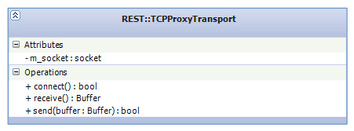
The proxy only needs to send the HTTP message and wait s the reply from the server. The send function will be use to send the request and the function receive will be use to wait and receive the reply.
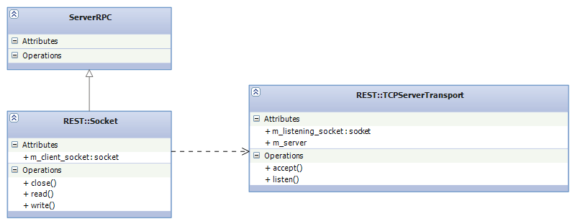
The transport used in the server needs to listen new TCP connections. The function listen will do this. When a new connection is detected, then the transport will be accept it. The function accept will accept the new TCP connection and then create a new socket. This socket will be use by the server to get the client's request and send the reply. This socket will be encapsulated in a REST::Socket class.

Proxy

DDS
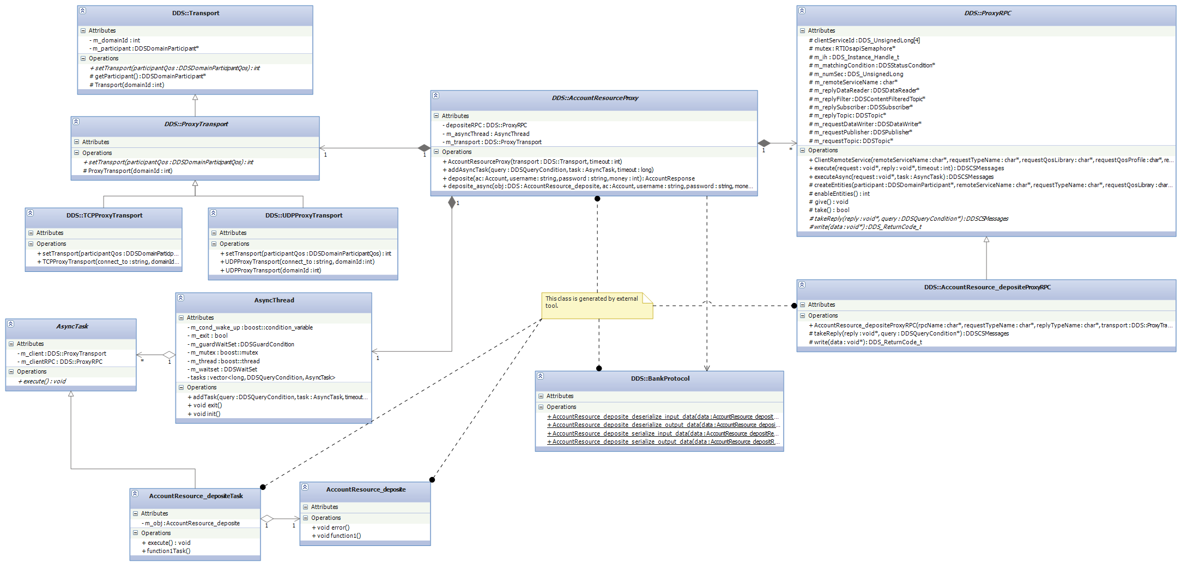
The new architecture of the client's side when RPCDDS over DDS is used is:

Proxy class
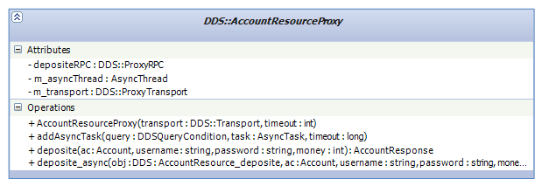
The proxy's class of an interface continue to be the frontend for the user. User can call remotely a server's procedure using the proxy's procedures. In our example the user can call the procedure deposite that the class DDS::AccountResourceProxy offers.
This class will use the generated protocol class to serialize the input parameters into a DDS type. In our example the class DDS::AccountResourceProxy will use the generated class DDS::BankProtocol. In the same way, this class will use the generated protocol class to deserialize the received DDS type into the output parameters.

RPC endpoint classes
Like in the old architecture, there will be one of these classes per remote procedure. These classes encapsulates the DDS entities for each generated topics. The proxy class will use these classes to send the DDS types and receive the replies from the server. These classes need the DDS::ProxyTransport to have access to the DDS::DomainParticipant entity.
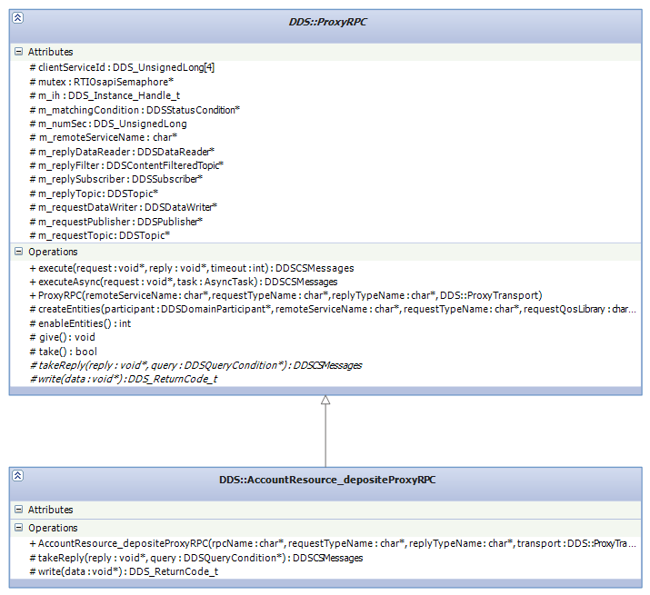
In our example there will be only one RPC endpoint class:

RESTful
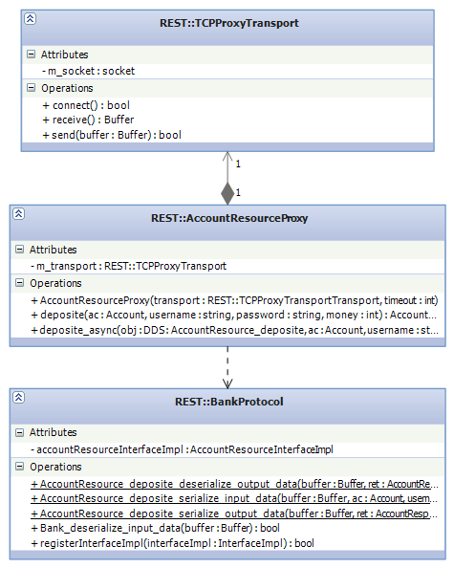
The new architecture of the client's side for RESTful is:

Proxy class
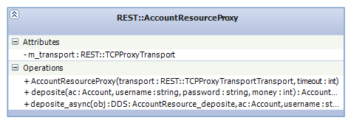
The proxy class for RESTful offers similar frontend to the user as the proxy for DDS. DifferIn our example the user can call the procedure deposite that the class DDS::BankProxy offers.

This class will use the generated protocol class to serialize the input parameters into a HTTP message. In our example the class REST::AccountResourceProxy will use the generated class DDS::BankProtocol. In the same way, this class will use the generated protocol class to deserialize the received HTTP message into the output parameters.
This proxy class will use directly the REST::TCPProxyTransport to send and receive the HTTP messages.

Server

Interface implementation
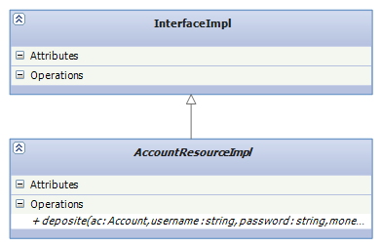
The new architecture will support several IDL interfaces. For each one the IDL compiler will generate a skeleton. This skeleton is the interface implementation and it has mapped all remote procedures of the interface. The user has to implement these procedures and their implementation will be executed each time a client calls the procedure remotely.

Strategies
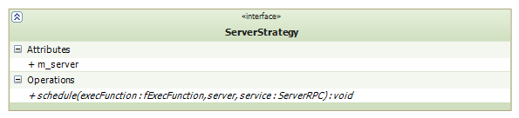
The new architecture has to support the server's strategies as the old architecture do. All strategies still inherit from a common interface. But this interface has to change because it has to be able to be used by DDS part and RESTful part.
This interface only has one function. This function receives the pointer of a function that will be called by the strategy to process the request. This pointer is named execFunction. Using DDS for each remote procedure will be generated a function that could be pointed by this pointer. These functions will process the remote procedure. In our example there is generated only one function and its name is AccountResource_deposite. Using RESTful there will be only one function for all requests. This function is generated and calls to the protocol class to detect the destination and extract the output parameters. In our example this function is named processHTTPmessage.

DDS
The new architecture of the server side when RPCDDS over DDS is used is:
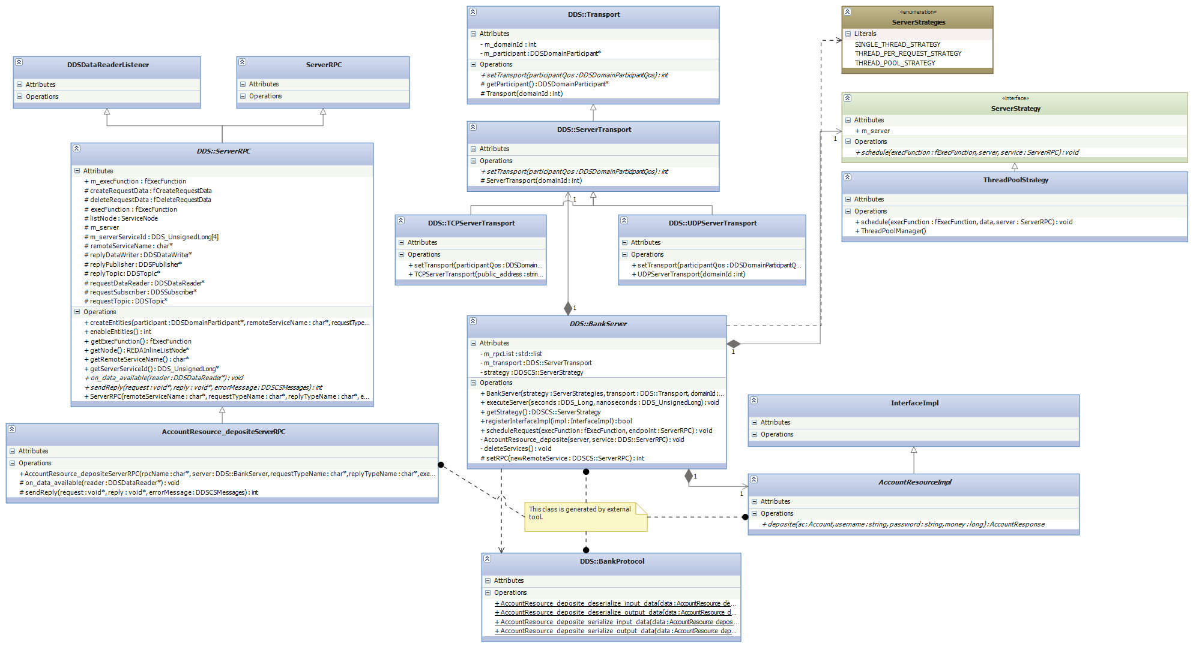

Server class
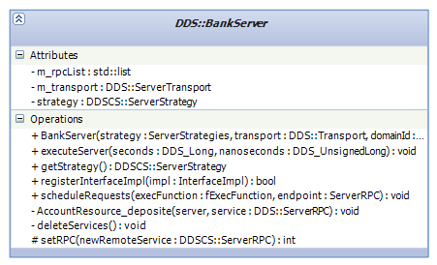
The server class is the main class in the server's side. This class will be used by the user to run the entire server. When the server is running this class will be notified that there are incoming requests and it will process them. The function scheduleRequests is used for this purpose. The server will read all new incoming requests and it will send one by one to the current server's strategy. Then for each request the server's strategy will call the generated function in the server class that process the type of the request. In our example the unique generated function is named AccountResource_deposite.
Although the server class is generated with all functions to process each type of request, only requests whose interface implementation is registered in the server class will be processed. To register an interface implementation, the user has to use the function registerInterfaceImpl.

RPC endpoint class
Like in the old architecture, there will be one of these classes per remote procedure. These classes encapsulates the DDS entities for each generated topics. These classes will detect that requests of a certain DDS type have been arrived and they will notify to the server class using its function scheduleRequests. Also the server class will use these classes to send the replies. These classes need the DDS::ServerTransport to have access to the DDS::DomainParticipant entity.
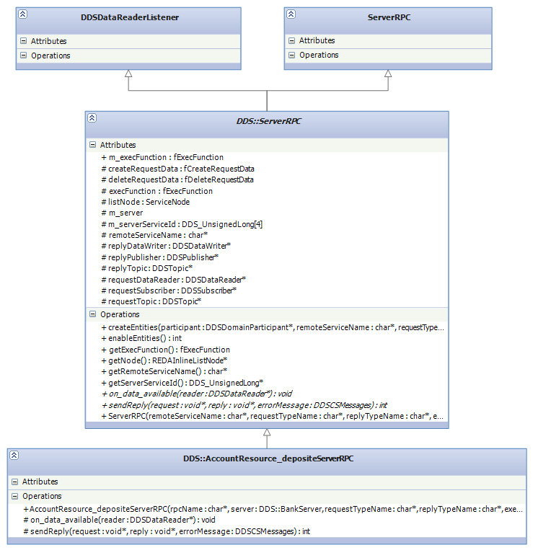
In our example there will be only one RPC endpoint class:

RESTful
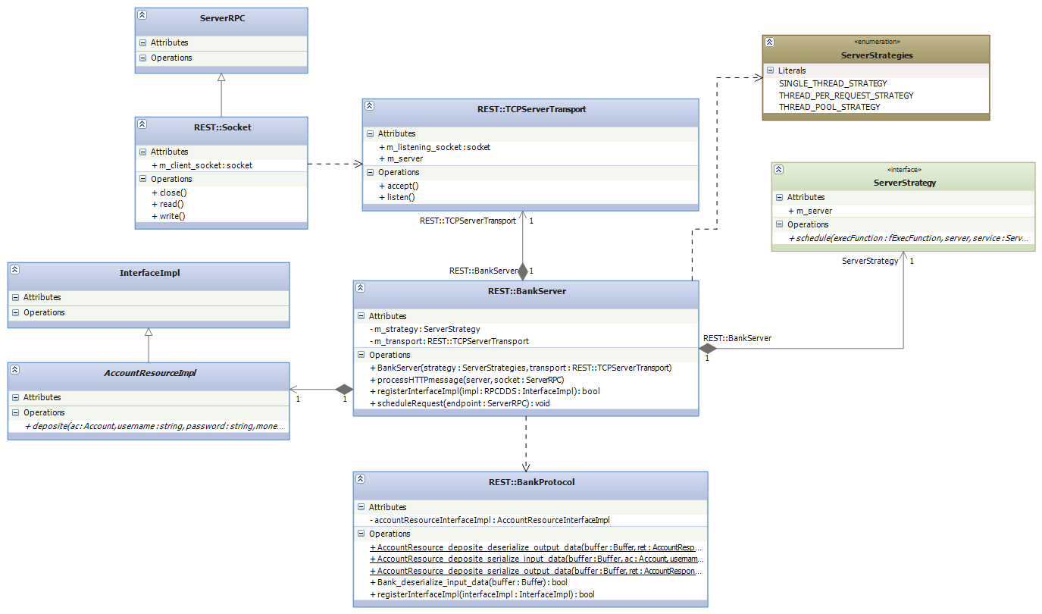
The new architecture of the client's side for RESTful is:

Server class
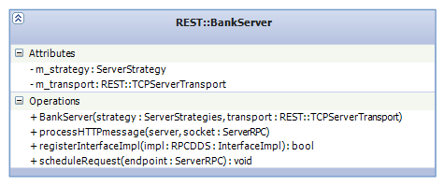
The server class is the main class in the server's side. This class will be used by the user to run the entire server. When the server is running this class will be notified by the TCPProxyTransport that there are incoming requests and it will process them. The function scheduleRequest is used for this purpose. The server will read the new incoming request using the auxiliary class REST::Socket and it will send it to the current server's strategy. The server's strategy will call the generated function in the server class that process the HTTP message and discover its destination. Always this generated function is named processHTTPmessage.

Behavior model
In this section is shown some functionality from sequence diagrams

DDS

Proxy initialization
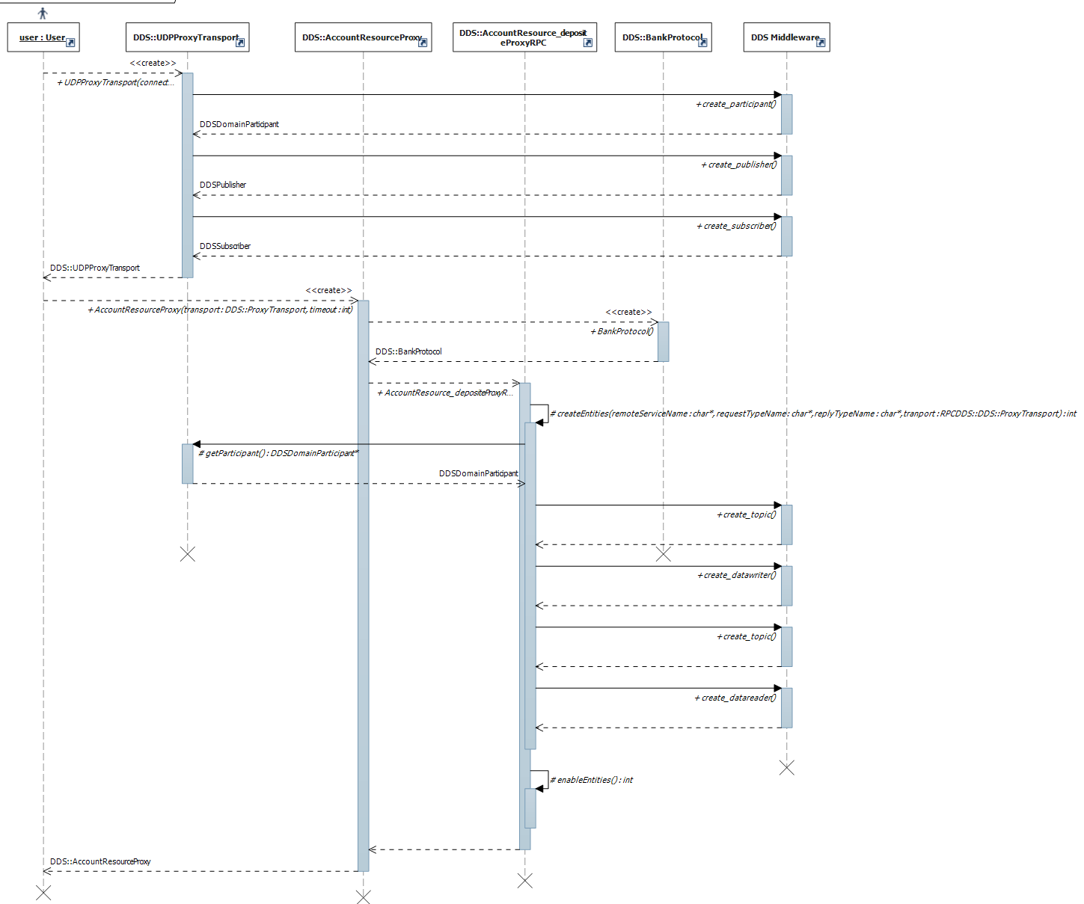

Using proxy to call a remote procedure synchronously
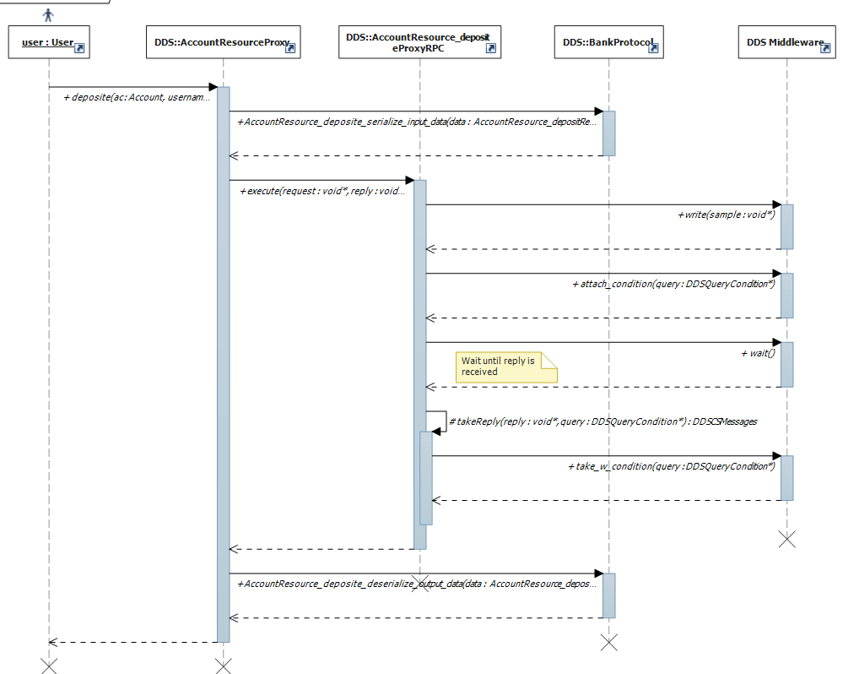

Server initialization
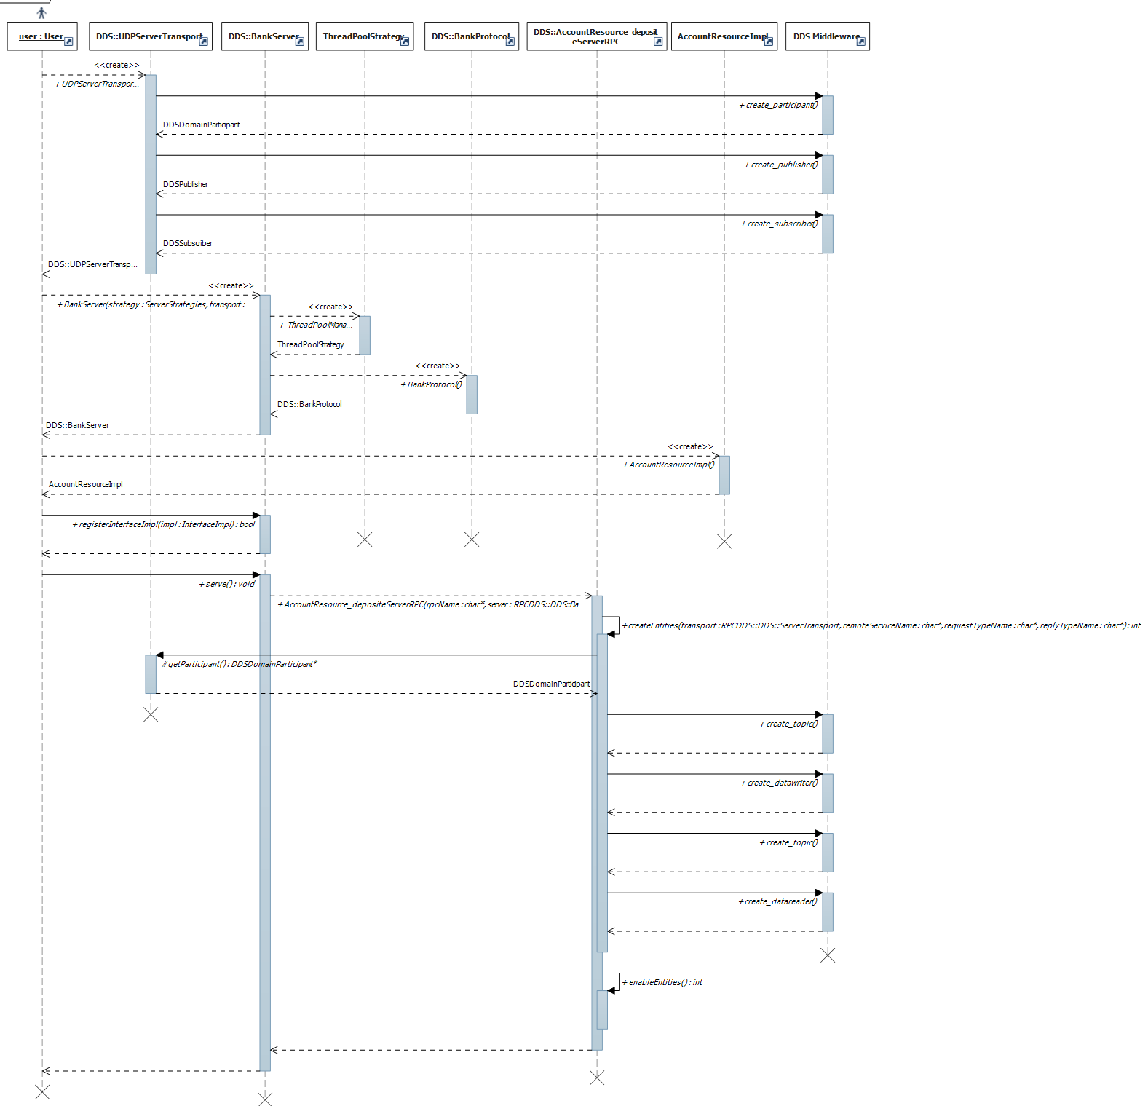

Server receives a request
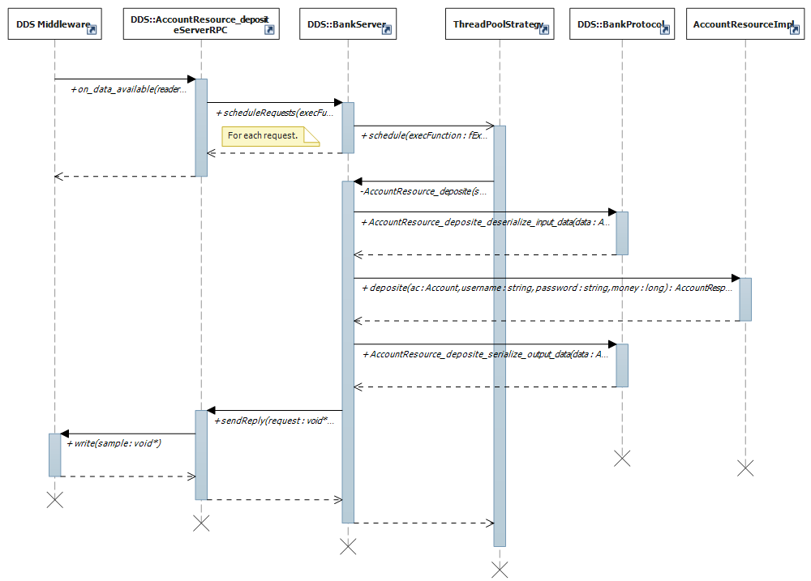

RESTful

Proxy initialization
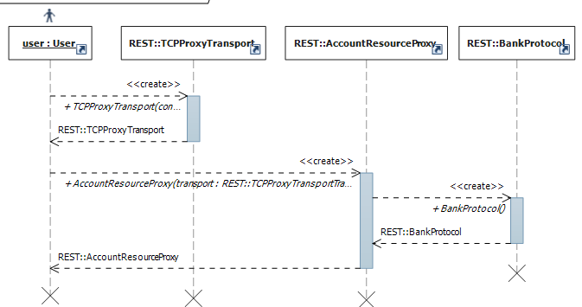

Using proxy to call a remote procedure synchronously
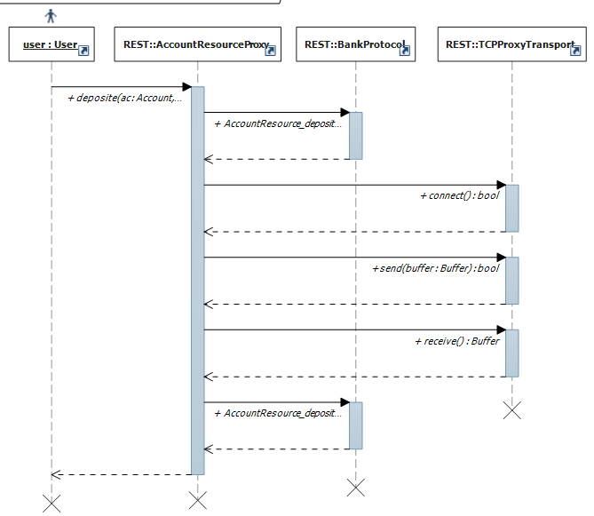

Server initialization
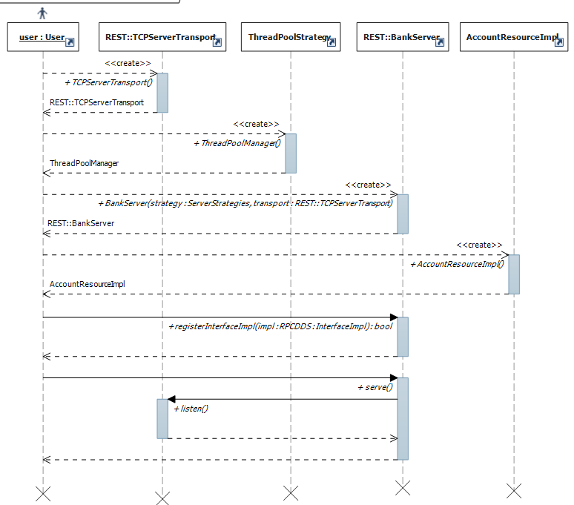

Server receives a request
